**Overview**

Very Rich GUI based python CSV editor, made with kivy python library, there was not a decent CSV editor made with python on GitHub, so I started making one myself, and then it have grown to a big project.

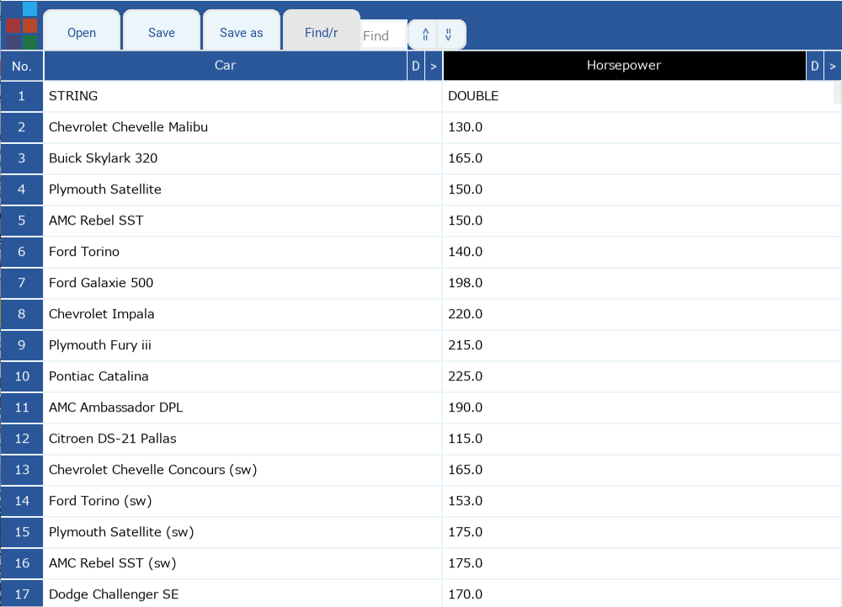

**Install instructions**

Install [Python 3.9.1](https://www.python.org/ftp/python/3.9.1/python-3.9.1-amd64.exe)

Make sure to run PyCSV Requirements Installer.bat before running the script. If you see any error messages, run it again, or install the requirements manually.

Run PyCSV.py

**Editor features:-**

**Configuration**

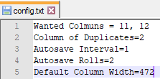

There's a config.txt file alongside the PyCSV script that has 5 lines currently.

**The first** line lets you define what columns will be in the main editor view. Wanted columns should be separated by a comma.

The rest of columns are added to the 'extra details' fields for that row (the extra details feature will be discussed later).

**The second** line is the auto save interval in minutes. For example, if you want the editor to auto save every minute, set it to 1.

**The third** line is the number of auto save backups that will be made before they get overwritten in a cycle, basically an rolling save scheme.

**The fourth** line is the default width for every column when the editor first starts. You can freely change the width of each column in the editor by left clicking and dragging the “**>”** on the right of the columns.

**The fifth** name of the custom “spello” model file for AI spell check.

**Navigation**

There are vertical and horizontal scroll bars. You can move the vertical bar with the mouse wheel. The horizontal scroll with the left/right arrows on the keyboard. You can shift up and down between cells by using up/down arrows on the keyboard.

**Find/Replace functions**



When you launch the app, you will find the “Find/r” switch. This starts in find mode from app launch. Clicking on Find/r switches it to replace mode. The find/ Replace function works on one column of your choosing. Click the name of the column you want to Search/ Replace on, and it will change colors to black. By default the last column on the right is pre-highlighted/ selected at app launch.

**Extra details**

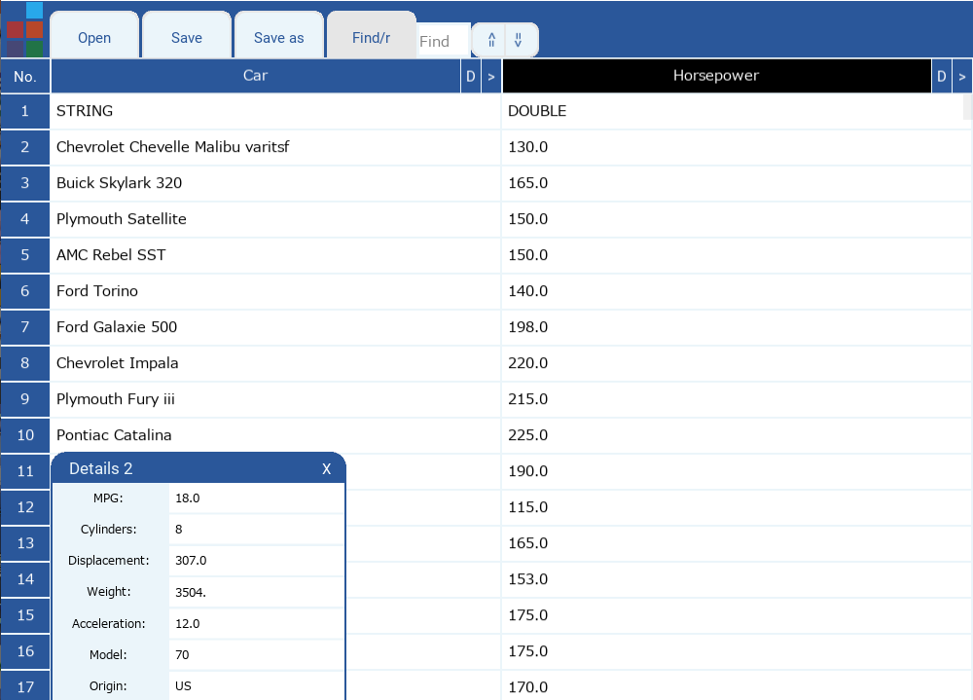

The 'extra details' fields can be accessed by right clicking on a row number. This includes any column data that was in the CSV file and not currently displayed for a row. It’s a floating window so you can move it with your mouse. Its size changes depending on the data inside. You can also edit any information in the ‘extra details’ fields.

**Duplicates marking and populating**



The duplicates finder function will make row numbers appear in two different colors, grey and silver. Grey rows have the original text, and the silver rows have the duplicates of an original text.

Activate this function by clicking the “D” button on the right of a column, this will run the duplicates finder function on that column.

Clicking on a silver row number will jump to the grey row of the original duplicate entry. Clicking on the grey row number jumps you back to the last silver row you clicked.

Editing an original row and hitting the 'insert' key (while the text field is in focus) will apply the changes you made on that row to all its duplicates.

Hitting CTRL + SHIFT + D will apply all changes made to all rows to all of their duplicates.

**Row highlighting**



Clicking a normal row (that has no duplicates) will change its color to black. When you highlight multiple rows, you can jump between them with the 'page up' and 'page down' buttons.

**Theme changer**



There's a theme changer in the top left. All Microsoft Office themes are included.

**Go To**



Clicking on the “No.” cell on top left will bring up a goto window. Type the row number and hit the enter key to jump to the specified row. Left clicking the “Go To” button will also work.

**Undo/Redo Bulk Operation**

You can undo/redo any bulk changes like replace/duplicates populating by hitting CTRL + Z and CTRL+SHIFT+Z **while there’s no cell currently selected** (if a cell is selected, you will undo/redo the changes only made to this cell).

**Cells resizing**

By CTRL and +/CTRL and -, you will increase/decrease the size and the font size of all the cells.

**Auto save**

You can change the auto save interval time by setting the “Auto save interval” in the config.txt. Intervals are counted in minutes.

**Spellcheck**

While writing in any cell, a suggestion will be listed if the current word you are writing has a misspelling. Hitting enter, or clicking the suggestion, will apply it. The spell check is A.I. based. And works for custom trained “spello” models, you can specify the name of the custom model in the last line of the config.